CO3 AT1 EXPERIMENTS
NAME:V.RAKSHMITHA
REG.NO:192465052
Experiment 1: Password Hashing with Salting and Key Stretching
Aim
To design and implement a password hashing system using salting and key stretching in C, and demonstrate how these techniques improve resistance against brute-force and rainbow-table attacks.
Algorithm
- Start the program.
- Read the password from the user.
- Generate a random salt.
- Combine the password with the generated salt.
- Apply a hashing operation.
- Repeat the hashing process multiple times to perform key stretching.
- Store the resulting hash and salt.
- Ask the user to enter the password again.
- Hash the entered password using the same salt and number of iterations.
- Compare the newly generated hash with the stored hash.
- If both hashes match, display Password verification successful.
- Otherwise, display Invalid password.
- Stop the program.
PROGRAM:
#include <stdio.h>
#include <string.h>
#include <stdlib.h>
#include <time.h>

#define SALT_LEN 16
#define HASH_LEN 32
#define ITERATIONS 10000

void simple_hash(const char *password, const char *salt,
unsigned long hash[HASH_LEN])
{
int i, j;
unsigned long value;

for (i = 0; i < HASH_LEN; i++)
hash[i] = 0;

for (i = 0; password[i] != '\0'; i++)
{
value = (unsigned long)password[i];

for (j = 0; j < HASH_LEN; j++)
hash[j] = (hash[j] * 31 + value + j) % 1000003;
}

for (i = 0; salt[i] != '\0'; i++)
{
value = (unsigned long)salt[i];

for (j = 0; j < HASH_LEN; j++)
hash[j] = (hash[j] * 17 + value + j) % 1000003;
}
}

void stretched_hash(const char *password, const char *salt,
unsigned long hash[HASH_LEN])
{
int i;

simple_hash(password, salt, hash);

for (i = 0; i < ITERATIONS; i++)
{
char temp[50];

sprintf(temp, "%lu", hash[0]);

simple_hash(temp, salt, hash);
}
}

void print_hash(unsigned long hash[HASH_LEN])
{
int i;

for (i = 0; i < HASH_LEN; i++)
printf("%08lu", hash[i]);

printf("\n");
}

int main()
{
char password[100];
char entered[100];

char salt[SALT_LEN + 1];

unsigned long stored_hash[HASH_LEN];
unsigned long new_hash[HASH_LEN];

int i;
int match = 1;

srand((unsigned int)time(NULL));

printf("PASSWORD HASHING WITH SALTING\n");
printf("==============================\n");

printf("\nEnter password: ");
scanf("%99s", password);

/* Generate random salt */
for (i = 0; i < SALT_LEN; i++)
{
salt[i] = 'A' + rand() % 26;
}

salt[SALT_LEN] = '\0';

printf("\nGenerated Salt: %s\n", salt);

/* Generate password hash */
stretched_hash(password, salt, stored_hash);

printf("Stored Password Hash: ");
print_hash(stored_hash);

printf("\nEnter password for verification: ");
scanf("%99s", entered);

/* Hash entered password */
stretched_hash(entered, salt, new_hash);

/* Compare hashes */
for (i = 0; i < HASH_LEN; i++)
{
if (stored_hash[i] != new_hash[i])
{
match = 0;
break;
}
}

if (match)
printf("\nPassword verification successful.\n");
else
printf("\nInvalid password.\n");

printf("\nKey Stretching Iterations: %d\n", ITERATIONS);

return
OUTPUT:
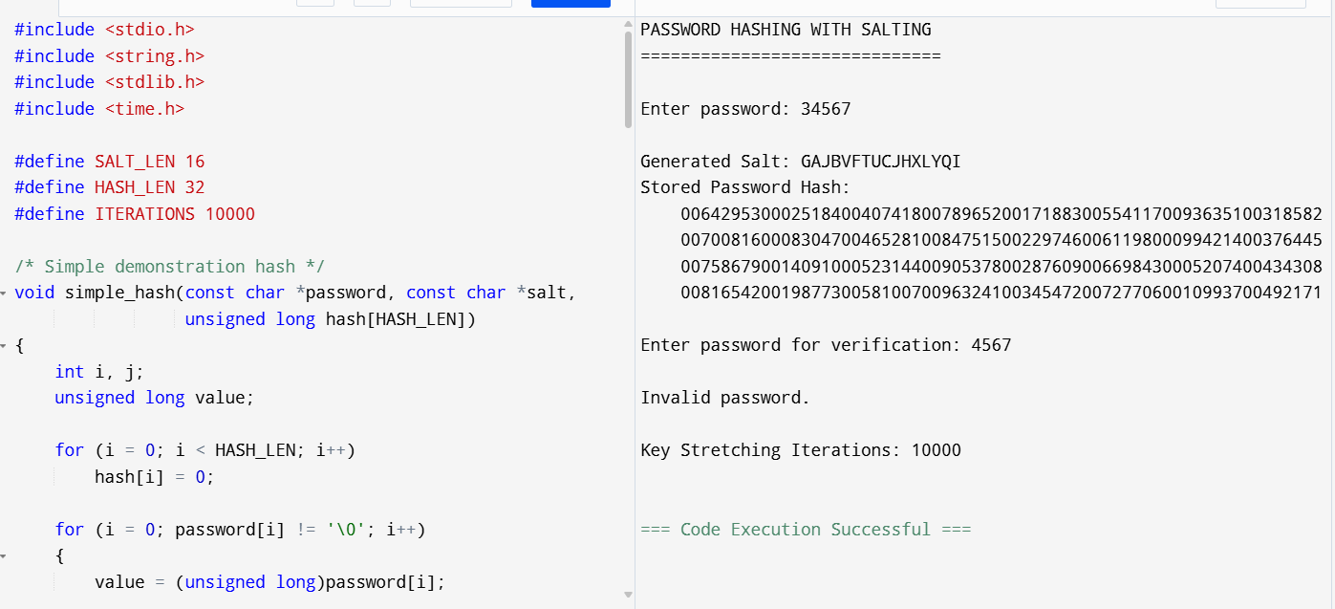

EXPERIMENT 2: Implementation of HMAC for Message Integrity
Aim
To implement a simplified HMAC using SHA-256 concept in C and demonstrate how a secret key can be used to verify the integrity and authenticity of a message.
Algorithm
- Start the program.
- Read the message from the user.
- Read the secret key.
- Generate a hash using the message and secret key.
- Display the generated HMAC value.
- Ask the user to enter the message again for verification.
- Generate the HMAC for the entered message using the same key.
- Compare the two HMAC values.
- If they match, the message is authentic and unchanged.
- Otherwise, the message has been modified.
- Stop.
PROGRAM:
#include <stdio.h>
#include <string.h>

#define HASH_SIZE 8

void generate_hmac(char message[], char key[], unsigned long hash[])
{
int i, j;
unsigned long value;

for (i = 0; i < HASH_SIZE; i++)
hash[i] = 0;

/* Process key */
for (i = 0; key[i] != '\0'; i++)
{
value = (unsigned long)key[i];

for (j = 0; j < HASH_SIZE; j++)
hash[j] = (hash[j] * 31 + value + j) % 1000003;
}

/* Process message */
for (i = 0; message[i] != '\0'; i++)
{
value = (unsigned long)message[i];

for (j = 0; j < HASH_SIZE; j++)
hash[j] = (hash[j] * 37 + value + j) % 1000003;
}
}

void print_hmac(unsigned long hash[])
{
int i;

for (i = 0; i < HASH_SIZE; i++)
printf("%08lu", hash[i]);

printf("\n");
}

int main()
{
char message[200];
char key[100];
char verify_message[200];

unsigned long original_hash[HASH_SIZE];
unsigned long new_hash[HASH_SIZE];

int i;
int match = 1;

printf("HMAC MESSAGE INTEGRITY\n");
printf("======================\n");

printf("\nEnter message: ");
fgets(message, sizeof(message), stdin);
message[strcspn(message, "\n")] = '\0';

printf("Enter secret key: ");
fgets(key, sizeof(key), stdin);
key[strcspn(key, "\n")] = '\0';

generate_hmac(message, key, original_hash);

printf("\nGenerated HMAC: ");
print_hmac(original_hash);

printf("\nEnter message for verification: ");
fgets(verify_message, sizeof(verify_message), stdin);
verify_message[strcspn(verify_message, "\n")] = '\0';

generate_hmac(verify_message, key, new_hash);

for (i = 0; i < HASH_SIZE; i++)
{
if (original_hash[i] != new_hash[i])
{
match = 0;
break;
}
}

if (match)
printf("\nMessage is authentic and unchanged.\n");
else
printf("\nMessage has been modified.\n");

return 0;
}

OUTPUT:
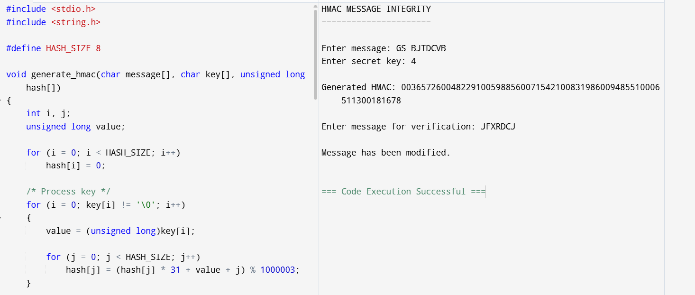

EXPERIMENT 3: Simulation of Certificate Chain Validation
Aim
To simulate X.509 certificate chain validation in C and demonstrate how trust is established from a Root CA to an End-Entity certificate.
Algorithm
- Start the program.
- Create a Root CA certificate.
- Create an Intermediate CA certificate.
- Create an End-Entity certificate.
- Check whether the Intermediate CA is issued by the Root CA.
- Check whether the End-Entity certificate is issued by the Intermediate CA.
- Check whether certificates are valid and not revoked.
- If all checks are successful, accept the certificate chain.
- Otherwise, reject the certificate chain.
- Stop.
PROGRAM:
#include <stdio.h>
#include <string.h>

struct Certificate
{
char subject[50];
char issuer[50];
int valid;
int revoked;
};

int main()
{
struct Certificate root;
struct Certificate intermediate;
struct Certificate server;

strcpy(root.subject, "Root CA");
strcpy(root.issuer, "Root CA");
root.valid = 1;
root.revoked = 0;

strcpy(intermediate.subject, "Intermediate CA");
strcpy(intermediate.issuer, "Root CA");
intermediate.valid = 1;
intermediate.revoked = 0;

strcpy(server.subject, "www.example.com");
strcpy(server.issuer, "Intermediate CA");
server.valid = 1;
server.revoked = 0;

printf("X.509 CERTIFICATE CHAIN VALIDATION\n");
printf("==================================\n");

printf("\nRoot CA: %s\n", root.subject);

if (root.valid && !root.revoked)
{
printf("Root CA: TRUSTED\n");
}
else
{
printf("Root CA: INVALID\n");
return 0;
}

printf("\nIntermediate CA: %s\n",
intermediate.subject);

if (strcmp(intermediate.issuer, root.subject) == 0 &&
intermediate.valid &&
!intermediate.revoked)
{
printf("Intermediate CA: VALID\n");
}
else
{
printf("Intermediate CA: INVALID\n");
return 0;
}

printf("\nEnd Entity: %s\n", server.subject);

if (strcmp(server.issuer, intermediate.subject) == 0 &&
server.valid &&
!server.revoked)
{
printf("End Entity Certificate: VALID\n");
}
else
{
printf("End Entity Certificate: INVALID\n");
return 0;
}

printf("\nCertificate Chain: VALID\n");
printf("Trust established successfully.\n");

return 0;
}
OUTPUT:
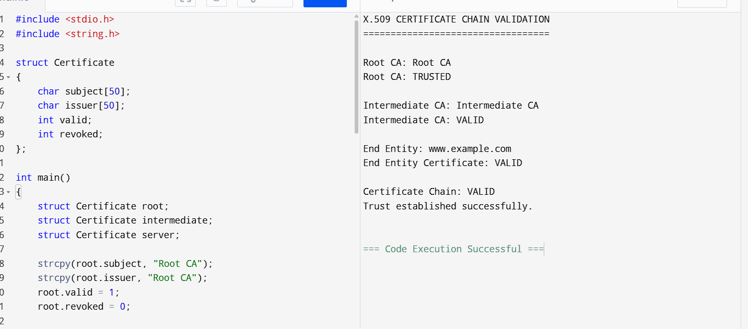

EXPERIMENT 4: Replay Attack Simulation and Prevention
Aim
To simulate a replay attack in an authentication system and prevent the attack using a unique nonce.
Algorithm
- Start the program.
- Generate a unique nonce.
- Send the nonce with the authentication request.
- Store the used nonce.
- Accept the first authentication request.
- Simulate an attacker replaying the same nonce.
- Compare the received nonce with the previously used nonce.
- If the nonce was already used, reject the request.
- Otherwise, accept the request.
- Stop.
PROGRAM:
#include <stdio.h>
#include <stdlib.h>
#include <time.h>

int main()
{
int nonce;
int received_nonce;
int used_nonce = -1;

srand((unsigned int)time(NULL));

printf("REPLAY ATTACK SIMULATION\n");
printf("========================\n");

/* Generate nonce */
nonce = rand() % 900000 + 100000;

printf("\nGenerated Nonce: %d\n", nonce);

/* First authentication */
received_nonce = nonce;

printf("\nFirst Authentication Request\n");

if (received_nonce == used_nonce)
{
printf("Replay detected.\n");
}
else
{
printf("Authentication successful.\n");

/* Store nonce */
used_nonce = received_nonce;
}

/* Simulate replay attack */
printf("\nAttacker replays the same nonce...\n");

received_nonce = nonce;

if (received_nonce == used_nonce)
{
printf("Replay attack detected and rejected.\n");
}
else
{
printf("Authentication successful.\n");
}

return 0;
}
OUTPUT:
